# Camille's Corner App

This app was created by me and some of my friends as a mock social media influencer platform for our friend Camille. It is a single page application built using react and react-router that combines a blog, forum, and store app all into one.

## Pages

This site has five main pages: Home, About, Blog, Forum, and Store.

### Home



This page is the landing page for users. Here they are shown a little bit about Camille, her most recent blog post, and new arrivals in her store. This page was deisgned so the user wasn't overwhelmed when first enetering this site, and could digests the various pages and where they wanted to go.

### About



This displays a short biography of Camille, and shows some of her social media posts.

### Blog



This page is a place for Camille to post updates about her life. This page has built in authentication, so only Camille can sign in a post updates, but other fans can sign up and leave comments on her posts!

### Forum

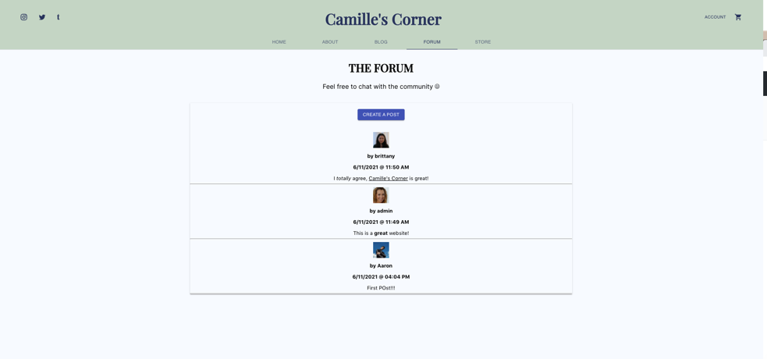

Here is a place for for Camille's fans to post questions and get answers from either other fans or Camille herself! This page was a later addition to the project, and could use some more styling.

### Store



This is a place for Camille to sell her products to her fans. Since this site was an excercise, and Camille does not actually have any fans/products, there is no way to actually purchase any items. But, my team and I belive the Stripe API could be implemented very easily.

## How this was built

This project is written in React and used react-router to manage the various pages. In addition to react, Google Firebase was used for the backend. We used a firestore database to store all of the data and users for this site, and used Node.js to build a custom API to interact with this database.

## Built By

David Hasani

Stephen Laming

Kayla Lewis

Brittany Sadoval-Rivera